Q1.
Hex Baron
Hex Baron is a two-player game in which players issue commands to control pieces on a grid of hexagonal tiles. The winner is the player who has the most victory points (VPs) at the end of the game.
When it is a player’s turn they give a series of three commands. Once all three commands have been given the program attempts to execute each command, in the order they were given. If an illegal command is given then that command will not be executed, but other commands given by the player will still be executed if they are legal. To successfully execute a command some of the resources in a player’s supply might need to be used (lumber, fuel and spare pieces).
The five available commands are:
• move, used to move a piece from one tile to another
• upgrade, used to change a piece into another type of piece
• spawn, used to create a new piece
• saw, used to obtain lumber
• dig, used to obtain fuel.
Each tile:
• has an ID
• has a type of terrain
• has (x, y, z) coordinates
• is either empty or contains a piece.
The different types of terrain are:
• forest (represented by the # symbol)
• peat bog (represented by the ~ symbol)
• field (represented by a space).
In the default game there is a grid size of 8, which means that there are 32 tiles in the grid. Each tile is stored in a list and the position (index) of the tile in the list is used to identify it. The coordinates of the tile are sometimes used by the program, for example, when calculating the distance between two tiles.
Figure 1 shows the coordinates and indices for each of the tiles in the default game. The first number in a tile is the x-coordinate, the second number is the z-coordinate, the third number is the y-coordinate and the final number is the tile’s index (where it is in the list of tiles), which is its ID.
Figure 2 shows an example tile.
Figure 1
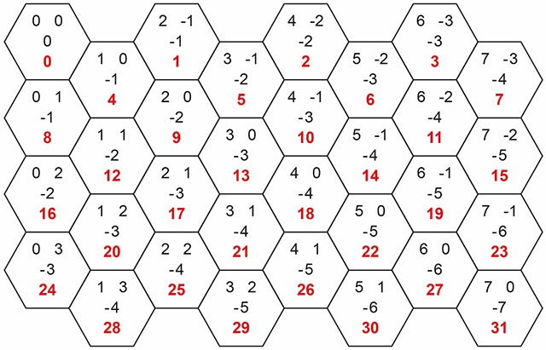
Figure 2
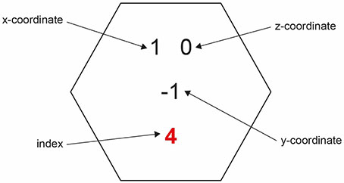
When the program displays the grid, for each tile it will show the type of terrain and, if there is a piece in the tile, the type of piece.
There are four different types of piece available in the game.

Piece | Movement | Other commands | Victory points
Baron | Can move to any neighbouring tile. This movement costs one fuel. |  | Worth ten victory points for opponent if destroyed.
Serf (the standard piece) | Can move to any neighbouring tile.  This movement costs one fuel unless it is moving to or from a peat bog tile in which case it costs two fuel. |  | Worth one victory point for opponent if destroyed.
Lumber Engineer Specialist Serf (LESS) | Can move to any neighbouring tile if it is currently in a field or peat bog tile.  This movement costs one fuel unless it is moving to or from a peat bog tile in which case it costs two fuel.  Cannot move if in a forest tile. | If given the saw command when in a forest tile will increase the player’s lumber supply by one. | Worth three victory points for opponent if destroyed.
Peat Bog Digger Serf (PBDS) | Can move to any neighbouring tile if it is currently in a field or forest tile. This movement costs two fuel.  Cannot move if in a peat bog tile. | If given the dig command when in a peat bog tile will increase the player’s fuel supply by either one or five.  The amount added depends on the result of a random number generation. | Worth two victory points for opponent if destroyed.
Player One’s pieces are displayed on the grid using uppercase letters (B, S, L, P); Player Two’s pieces are displayed using lowercase letters (b, s, l, p).
The upgrade command can be used to change one of the player’s serf pieces into a LESS or PBDS piece. When a piece is upgraded it costs five lumber.
The spawn command can only be successfully used on an empty tile next to the player’s baron piece. An empty tile is one that does not contain a piece. It will add a new serf piece in the specified tile. When a piece is spawned it reduces the number of spare pieces available in the player’s supply by one and it costs three lumber.
At the end of a turn the program checks to see if any pieces should be destroyed. A piece is destroyed if two (or more) of the tiles next to the tile the piece is in contain a piece.
The table below shows some example commands that could be given at the start of the default game with descriptions of what they would do.

Command | Description
upgrade less 8 | Lumber in Player One’s supply goes down by five to five.  The serf piece in tile 8 is replaced by a LESS piece.
saw 8 | It is a valid command as it has been used on a LESS piece but the piece is not in a forest tile so the saw action does not do anything.
move 0 1 | Not a valid move. Player One has got a piece in tile 0 but it cannot move to tile 1 so nothing changes.
Player One has given three commands so it is now Player Two’s turn.
upgrade pbds 31 | Tile 31 contains a baron piece so the upgrade will not work.
upgrade pbds 23 | Lumber in Player Two’s supply goes down by five to five.  The serf piece in tile 23 is replaced by a PBDS piece.
dig 23 | The amount of fuel in Player Two’s supply will, randomly, increase by either one or five. If it increased by five, the terrain of tile 23 will change from peat bog to field.
Player Two has given three commands so it is now Player One’s turn again.
move 8 12 | The amount of fuel in Player One’s supply will decrease by one.  The LESS piece moves from tile 8 to tile 12
saw 12 | The amount of lumber in Player One’s supply will increase by one to six.
saw 12 | The amount of lumber in Player One’s supply will increase by one to seven.
Player One has given three commands so it is now Player Two’s turn.
move 31 27 | The amount of fuel in Player Two’s supply will decrease by one.  The baron piece moves from tile 31 to tile 27
spawn 30 | The amount of lumber in Player Two’s supply will decrease by three.  The number of spare pieces in Player Two’s supply will decrease from five to four.  A new serf piece belonging to Player Two will be put in tile 30
spawn 26 | This command will not do anything as tile 26 is not next to tile 27 where the baron piece is.
That is the end of Player Two’s turn. The baron piece in tile 27 is now destroyed as two of the tiles next to it contain pieces (tiles 30 and 23). 10 victory points are given to Player One.
As Player One has more victory points than Player Two they are the winner.

